Grant Types Demo

Assumption: By default, realm is created with name (eazybankdev)
Resource Owner / End User – happy@example.com
Client – Postman
Auth Server – KeyCloak (deployed in local docker)
Resource Server - NA

Authorization Code Grant Type

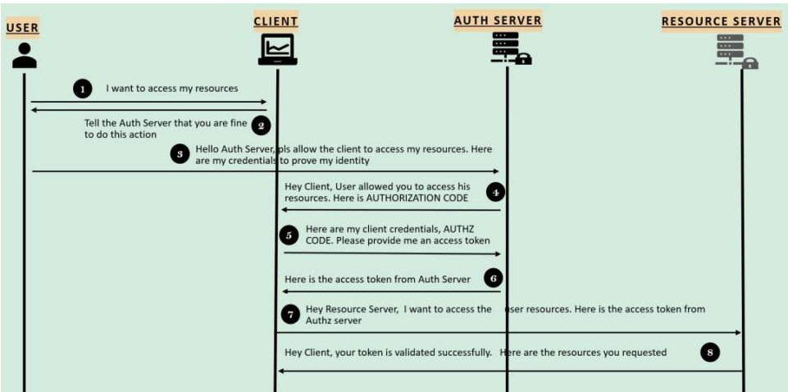

Step 1: Client Registration – Post registration, we will have ClientID & ClientSecret (optional)

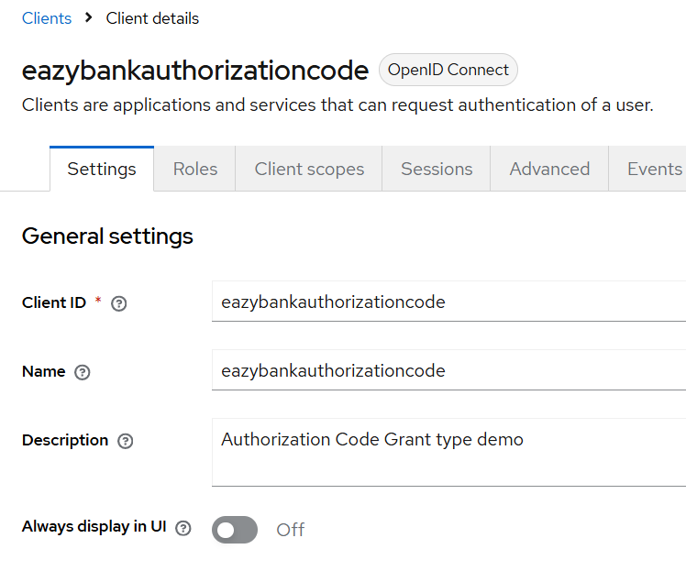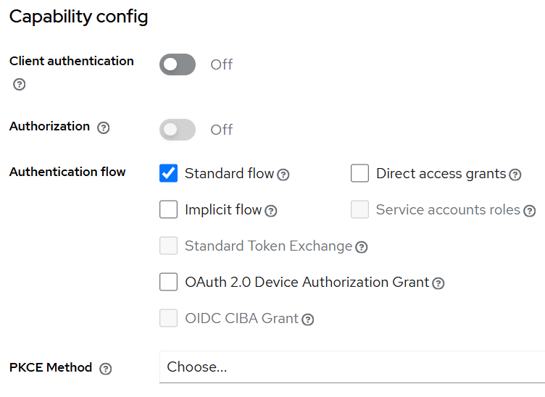

ClientID – eazybankauthorizationCode
ClientSecret – (Optional)

Step 2: Get token URI & Auth URL from below endpoint (under Realm setting – make sure you’ve selected the correct realm i.e., eazybankdev

OpenID Configuration - http://localhost:8180/realms/eazybankdev/.well-known/openid-configuration

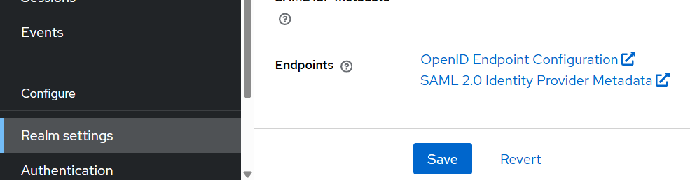

Step 3: Add all these configurations to Postman to generate Auth Code

Auth URL – http://localhost:8180/realms/eazybankdev/protocol/openid-connect/auth

Access Token URL - http://localhost:8180/realms/eazybankdev/protocol/openid-connect/token

State – Any Random value or Empty

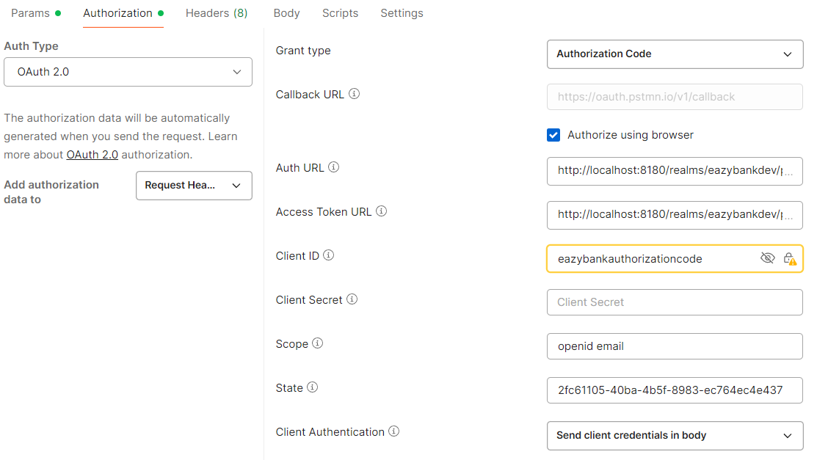

Step 4: Click on Get New Access Token Redirected to below Authorization URL

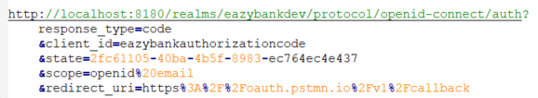

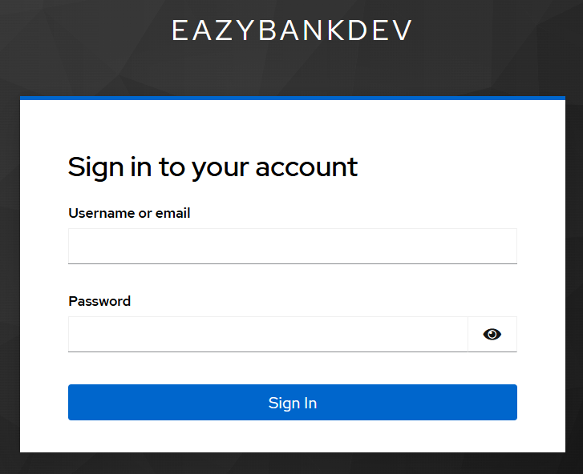

Step 5: On Sign in click, below authenticate with (302 status) will be invoked & User “happy” will be redirected back to the client, & we can notice a few additional query parameters in the URL of callback API (specifically state & code)

Callback URL - https://oauth.pstmn.io/v1/callback

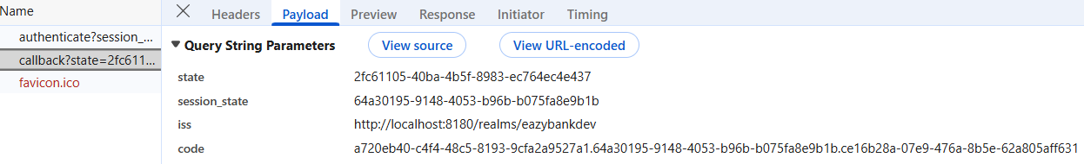

Note:
- We need to first verify that the “state” parameter (in the redirect) matches the value stored in this user’s session so that we protect against CSRF.
- Depending on how we’ve stored the “state” parameter (in a cookie, session or some other way), verify that it matches the state that we originally included in Step 3 & 4.

Step 6: Exchange the Authorization code: If state matches, we’re ready to exchange the Authorization Code for an Access Token.

(Step 3 part of OpenID Config):
Access Token URL - http://localhost:8180/realms/eazybankdev/protocol/openid-connect/token

The Client (e.g., Postman) will build a POST request to the token endpoint:

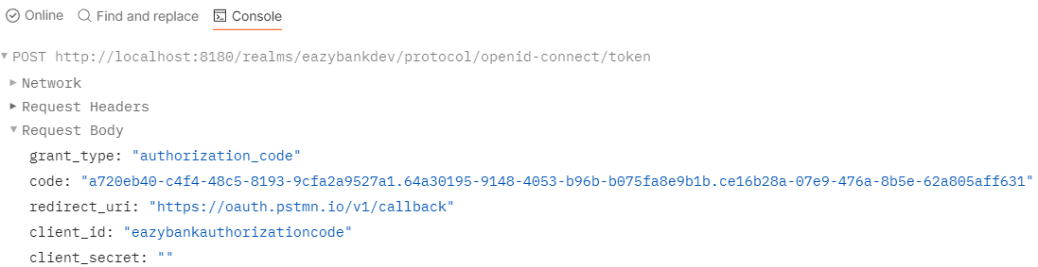

Note: The Client’s credentials are included in the POST body in this example. Other Authorization servers may require that the credentials are sent as HTTP Basic Authentication header.

OAuth 2.0 Authorization Code Flow conclusions

Step 1 – Build the authorization URL & redirect the user to the Authorization Server.

Step 2 – After the user is redirected back to the Client, verify the state matches

Step 3 – Exchange the Authorization code for an Access Token

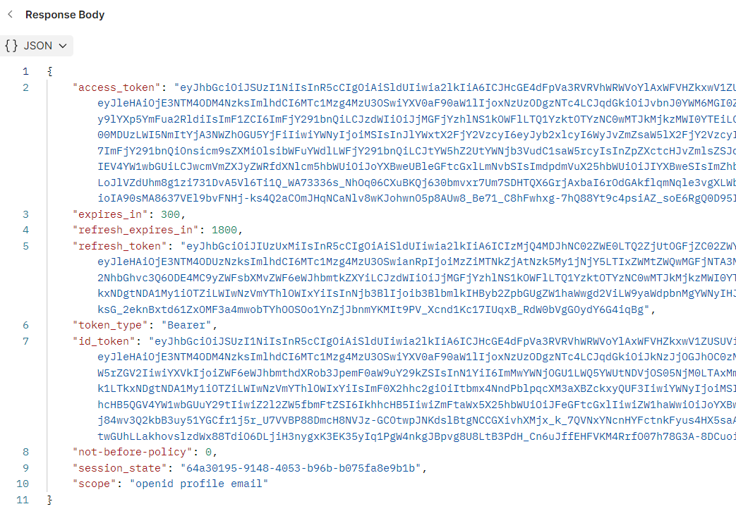

Note: We can use https://www.jwt.io/ to decode the all types of tokens.

Access Token
- An Access Token is a security token (JWT) issued by an Authorization Server as part of an OAuth 2.0 flow.
- It contains information about the user & the resources (Web APIs & protected resources) for which the token is intended.
- When an application needs to access protected resources, it includes the Access Token in the HTTP Authorization header as a Bearer token.

Refresh Token
- A Refresh token is a special token (JWT) that can be used to obtain new access tokens or ID tokens without requiring the user to re-authenticate.
- This is particularly useful for maintaining a seamless User experience in applications where users need continuous access over extended periods.
- By leveraging Refresh Token Grant Type, the access token will be regenerated.

Id Token
- An ID token is a JSON Web Token (JWT) that contains information about the user such as their unique identifier, name, email & other profile information.
- It is intended to be read by the Client application & is not meant for securing API requests. The ID token allows the client to verify the user’s identity & obtain basic profile information.
- While Access Tokens are used to access protected resources & Refresh tokens are used to obtain new Access Tokens, the ID Tokens are typically used to cache user information on the client side, reducing the need to make additional requests to the Authorization Server for user data.

Refresh Token Grant Type

- The Refresh Token Grant Type is used by Clients to exchange a Refresh Token for an Access Token when Access Token has expired.
- This grant type is supported for specific grant types such as Authorization Code, Resource Owner Password Credentials.
- The Client can make a POST request to the token endpoint & the response will include a New Access Token & optionally a New Refresh Token. Refer below:

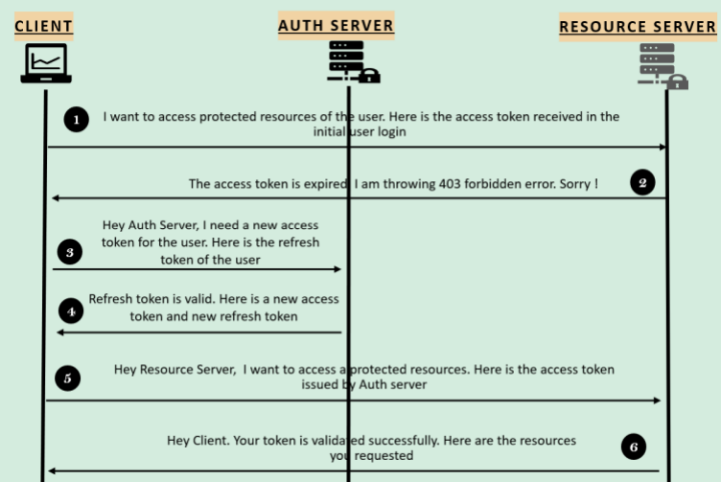

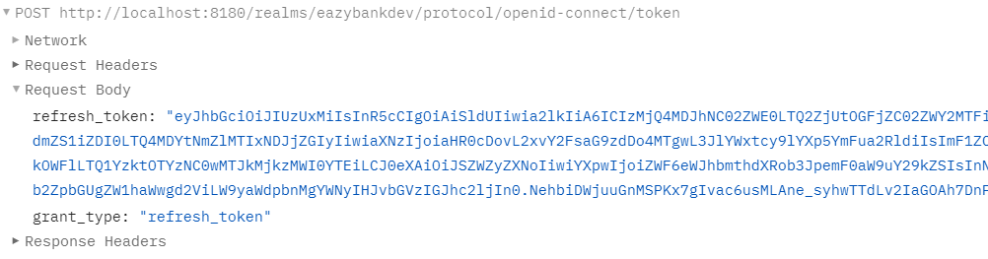
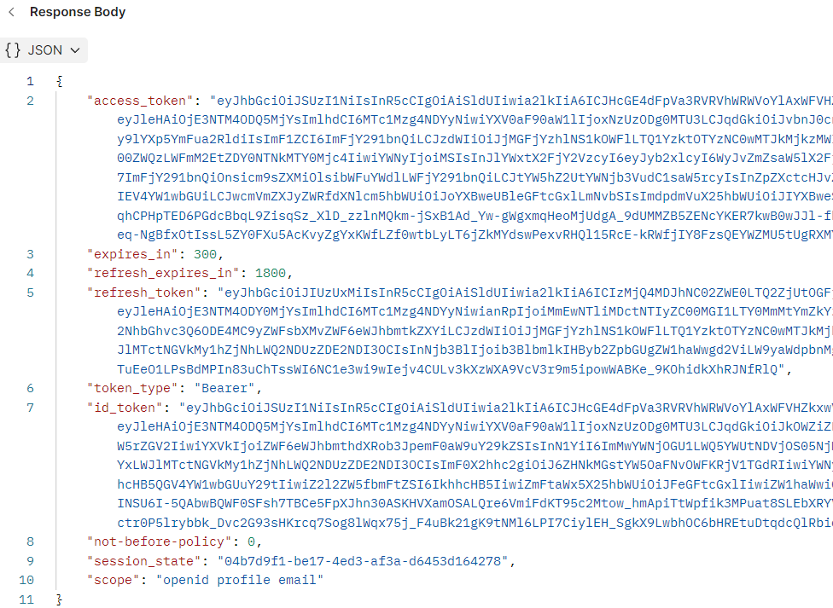

Authorization Code with PKCE (Proof Key for Code Exchange)

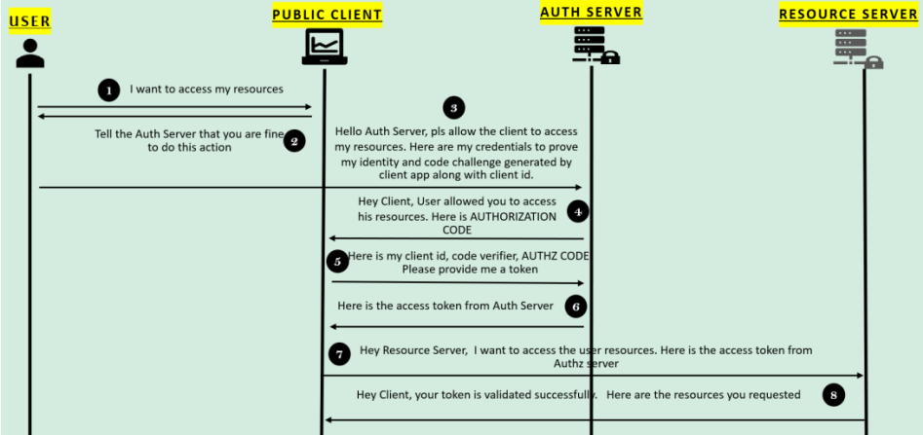

Step 1: Client Registration – Post registration, we will have ClientID, ClientSecret (optional), PKCE Method as S256

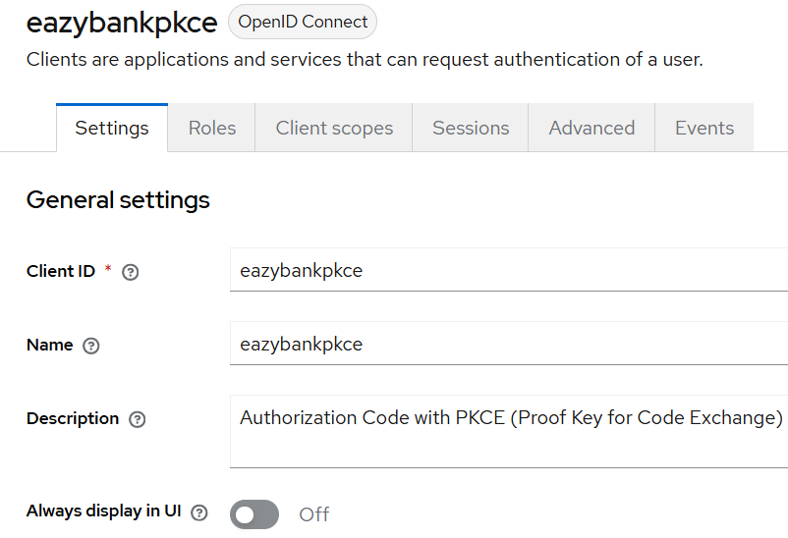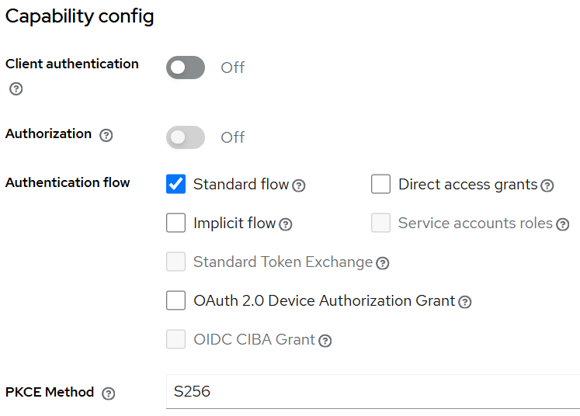

ClientID – eazybankpkce

Step 2: Create a code verifier & Challenge

- Before redirecting the end user to the Authorization server, the Client first generates a Secret Code Verifier & Challenge.
- The Code verifier is a cryptographically random string using characters A-Z, a-z, 0-9 & the punctuation characters (hyphen, period, underscore & tilde ~ )

- Client uses the generated Code verifier to create the Code challenge.
- For devices that can perform a SHA256 hash, the code challenge is a BASE64-URL-encoded string of the SHA256 hash of the code verifier. Otherwise, the same verifier string can be used as the Code Challenge.

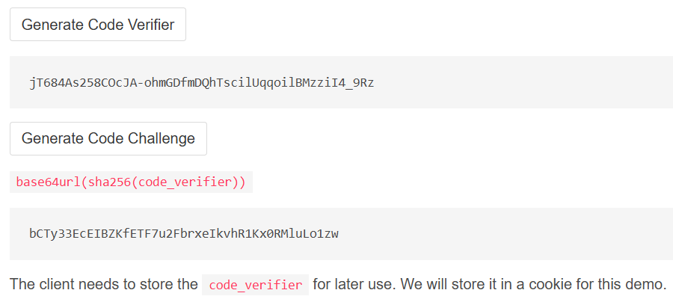

- For Postman, we can keep it empty. By default, postman will take care of it.

Step 3: Get token URI & Auth URL from below endpoint (under Realm setting – make sure you’ve selected the correct realm i.e., eazybankdev

OpenID Configuration - http://localhost:8180/realms/eazybankdev/.well-known/openid-configuration



Step 4: Add all these configurations to Postman to generate Auth Code

Auth URL – http://localhost:8180/realms/eazybankdev/protocol/openid-connect/auth

Access Token URL - http://localhost:8180/realms/eazybankdev/protocol/openid-connect/token

Code Challenge Method – SHA-256

Code Verifier – Generated in Step 2

Scope – openid email

State – Any Random value or Empty

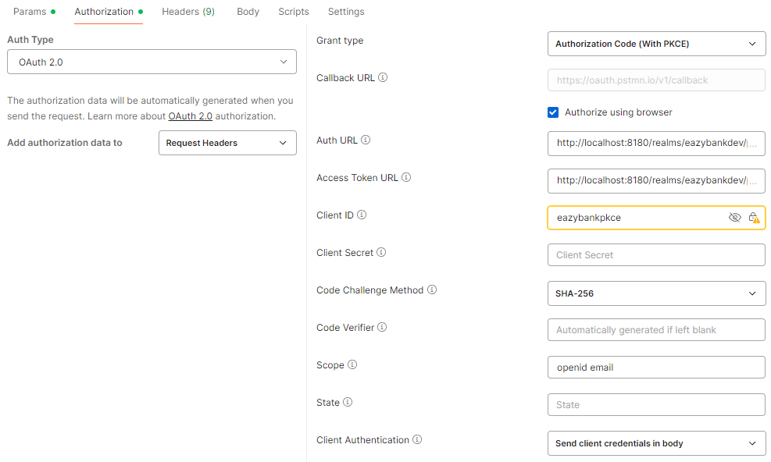

Step 5: Click on Get New Access Token Redirected to below Authorization URL

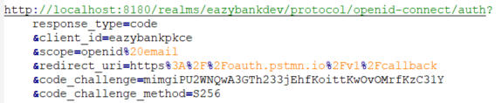



Note: The client includes the code_challenge parameter in the request, which the authorization server will store & compare later during the code exchange step.

Step 6: On Sign in click, below authenticate with (302 status) will be invoked & User “happy” will be redirected back to the client, & we can notice a few additional query parameters in the URL of callback API (specifically code)

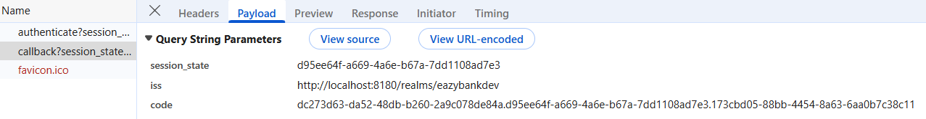

Note:
- The state value isn’t strictly necessary here since the PKCE parameters provide CSRF protection themselves.
- In practice, if we’re sure the OAuth server supports PKCE, we can use the state parameter for application state instead of using it for CSRF protection.

Step 7: Exchange the Authorization code

- The client will build a POST request to the token endpoint with below parameters:

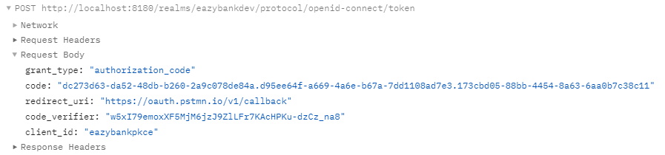

- We’ll need to send the code_verifier along with the token request. The Authorization server will check whether the verifier matches the challenge that was used in the Authorization request. This ensures that a malicious party that intercepted the Authorization code will not be able to use it.

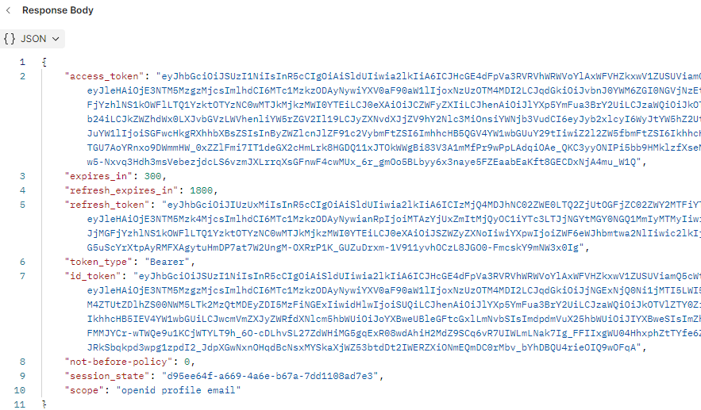

Client Credential Grant Type

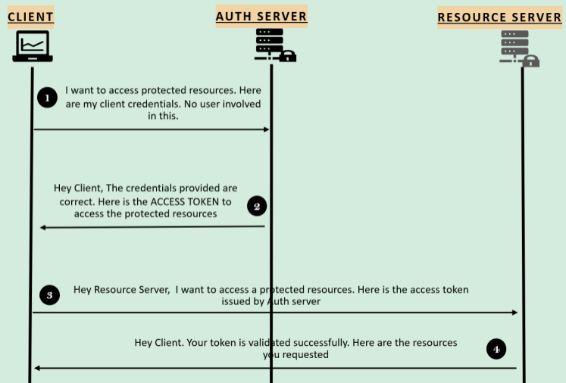

Step 1: Client Registration – Post registration, we will have ClientID, ClientSecret

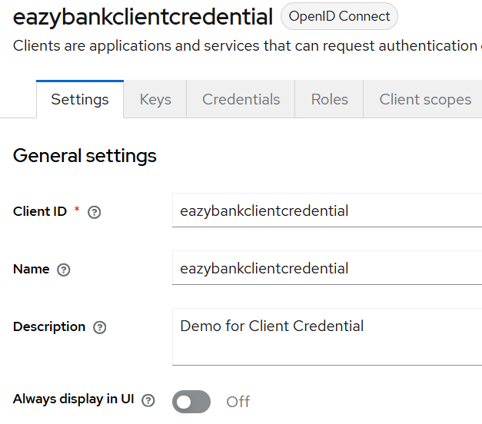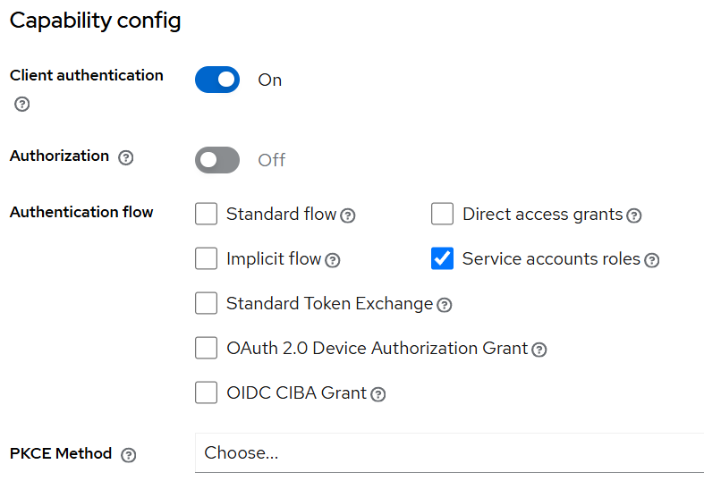

Client Id – eazybankclientcredential
Client Secret - d409AMxaAsOAsDUEEzGAnL72fjqsICtS

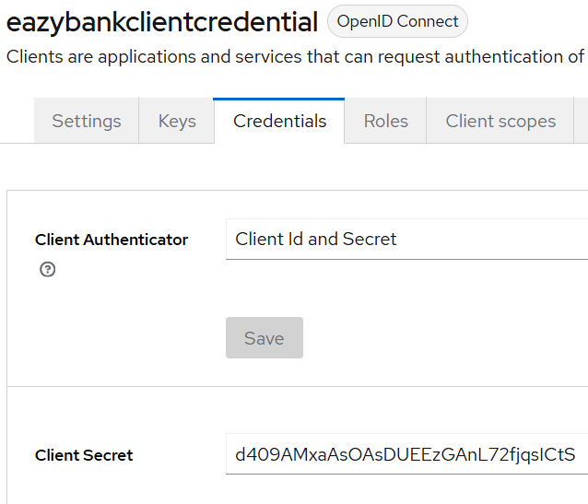

Step 2: Get token URI from below endpoint (under Realm setting – make sure you’ve selected the correct realm i.e., eazybankdev

OpenID Configuration - http://localhost:8180/realms/eazybankdev/.well-known/openid-configuration



Step 3: Add all these configurations to Postman to generate Access Token

Client Id, Client Secret
Access Token URL - http://localhost:8180/realms/eazybankdev/protocol/openid-connect/token

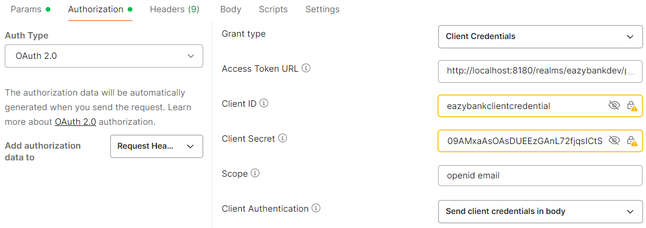

Step 3: Get Access Token (Exchange the Secret)

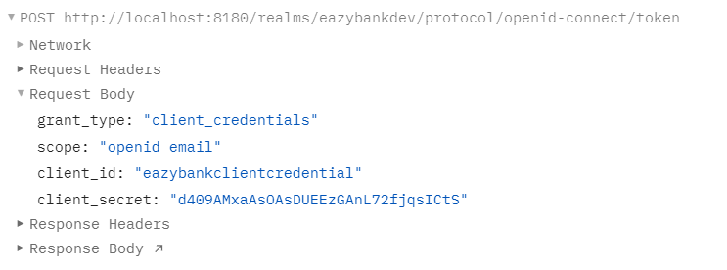
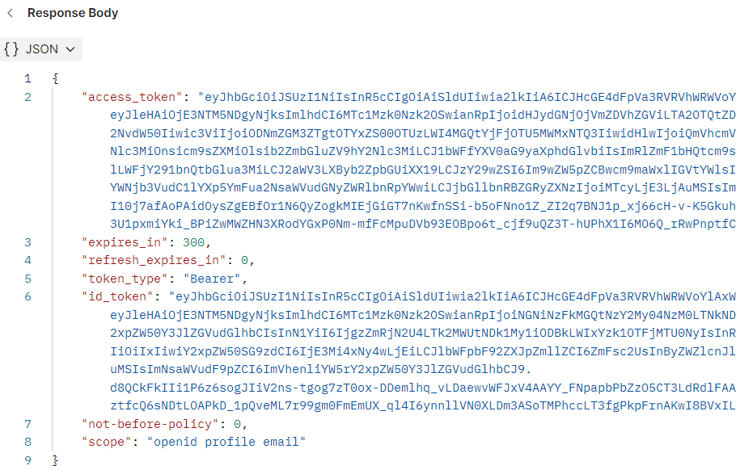

Note:

- Refer https://www.keycloak.org/documentation https://www.keycloak.org/docs-api/latest/rest-api/index.html for more details on how to configure users through APIs
- We can refer https://www.keycloak.org/guides for setting up Keycloak.
- We can use https://oauth.net/2/ , https://www.oauth.com/ , https://www.oauth.com/playground/ to explore all the in-depth OAuth2 details & grant types.

